RAPID MINER MODEL

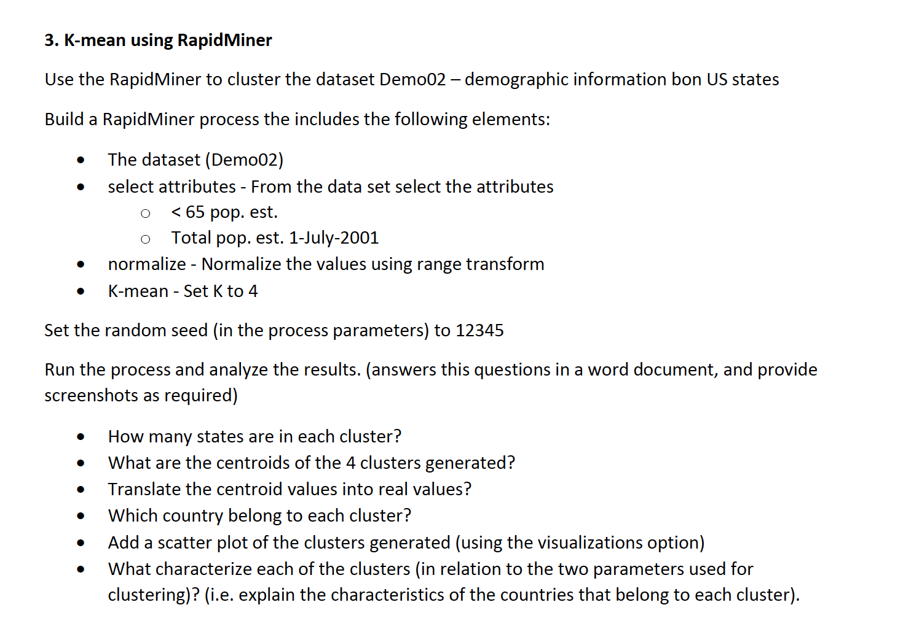

How to model: <https://www.youtube.com/watch?v=8m9t_bkEoiI>

FINAL MODEL

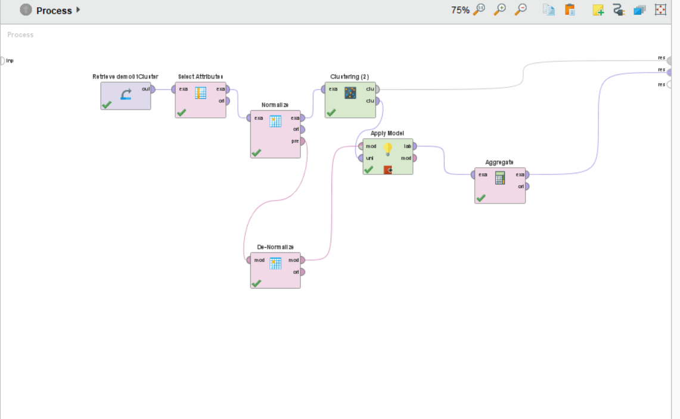

OUTPUT

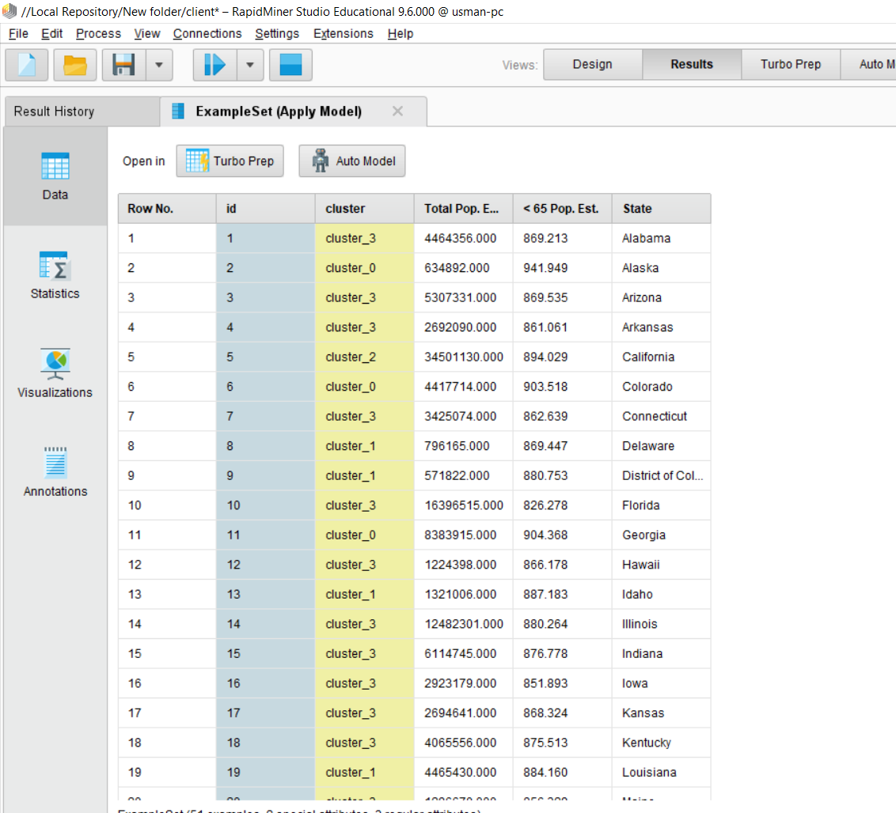

QUESTION ASKED IN THE DOCUMENT



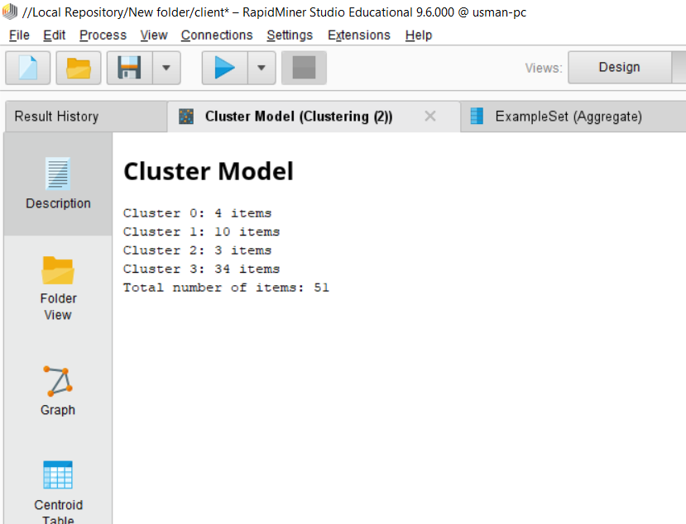



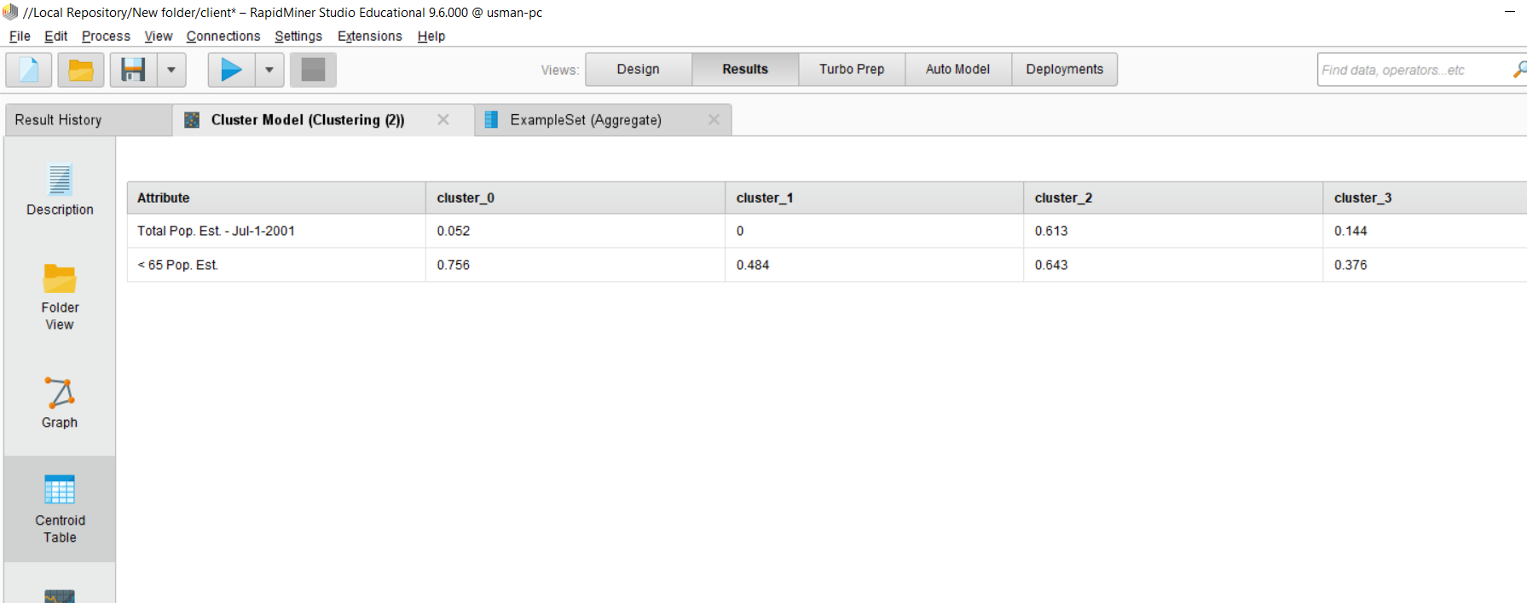



**This is a tricky question, kindly find the answers in the following link**

<https://community.rapidminer.com/discussion/13565/get-denormalized-k-means-centroids>

<https://www.screencast.com/t/1HO47i0w2y00>

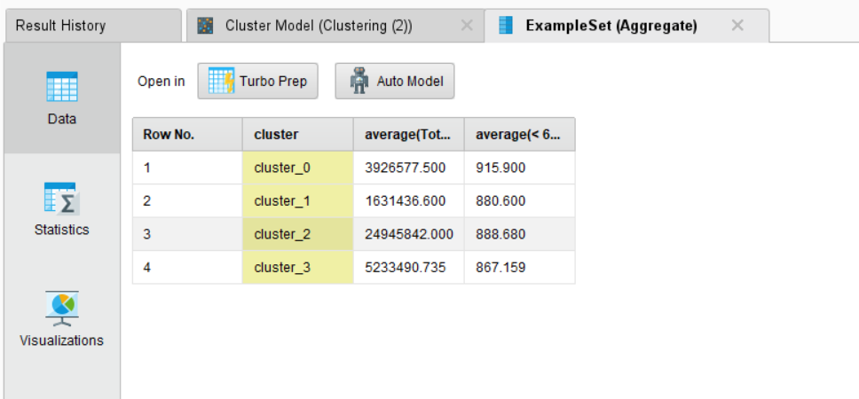



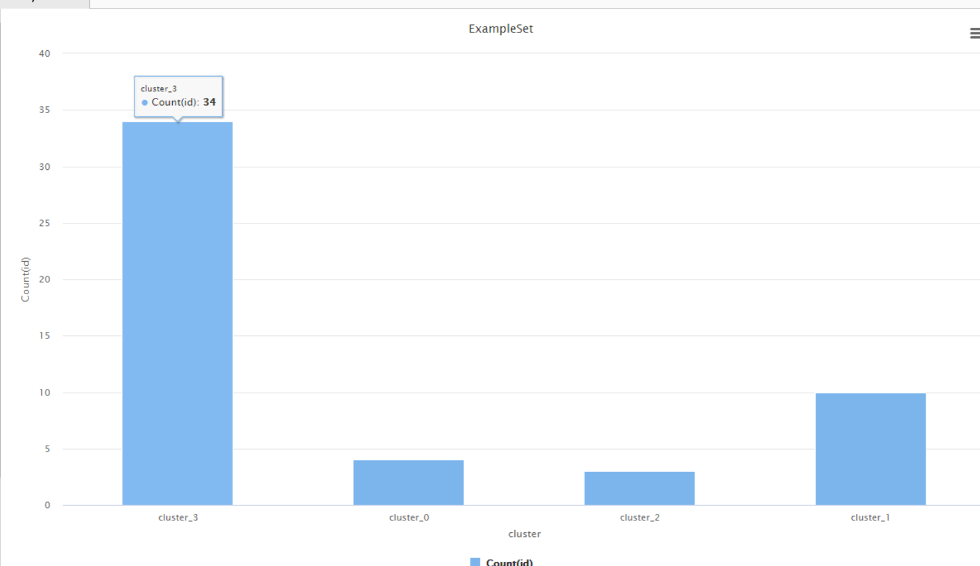

Countries name could be found in the output colums

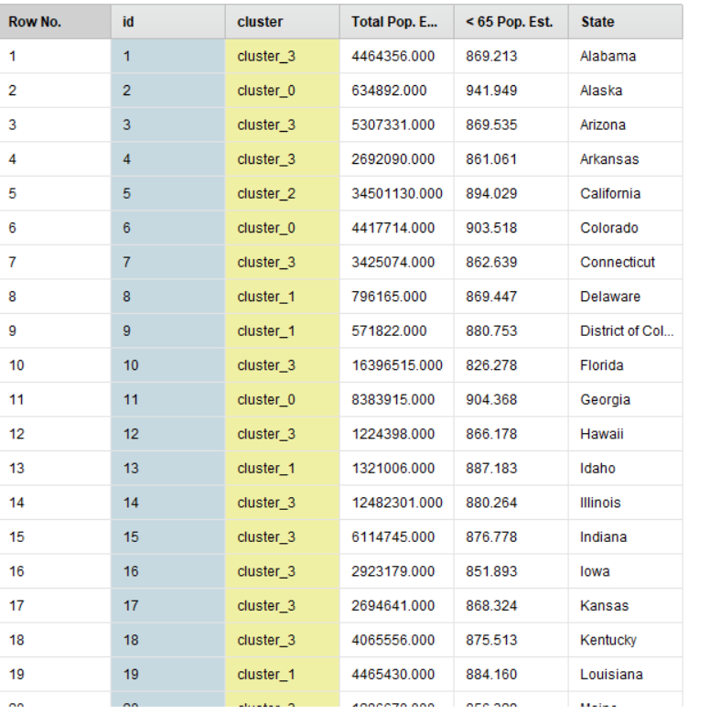



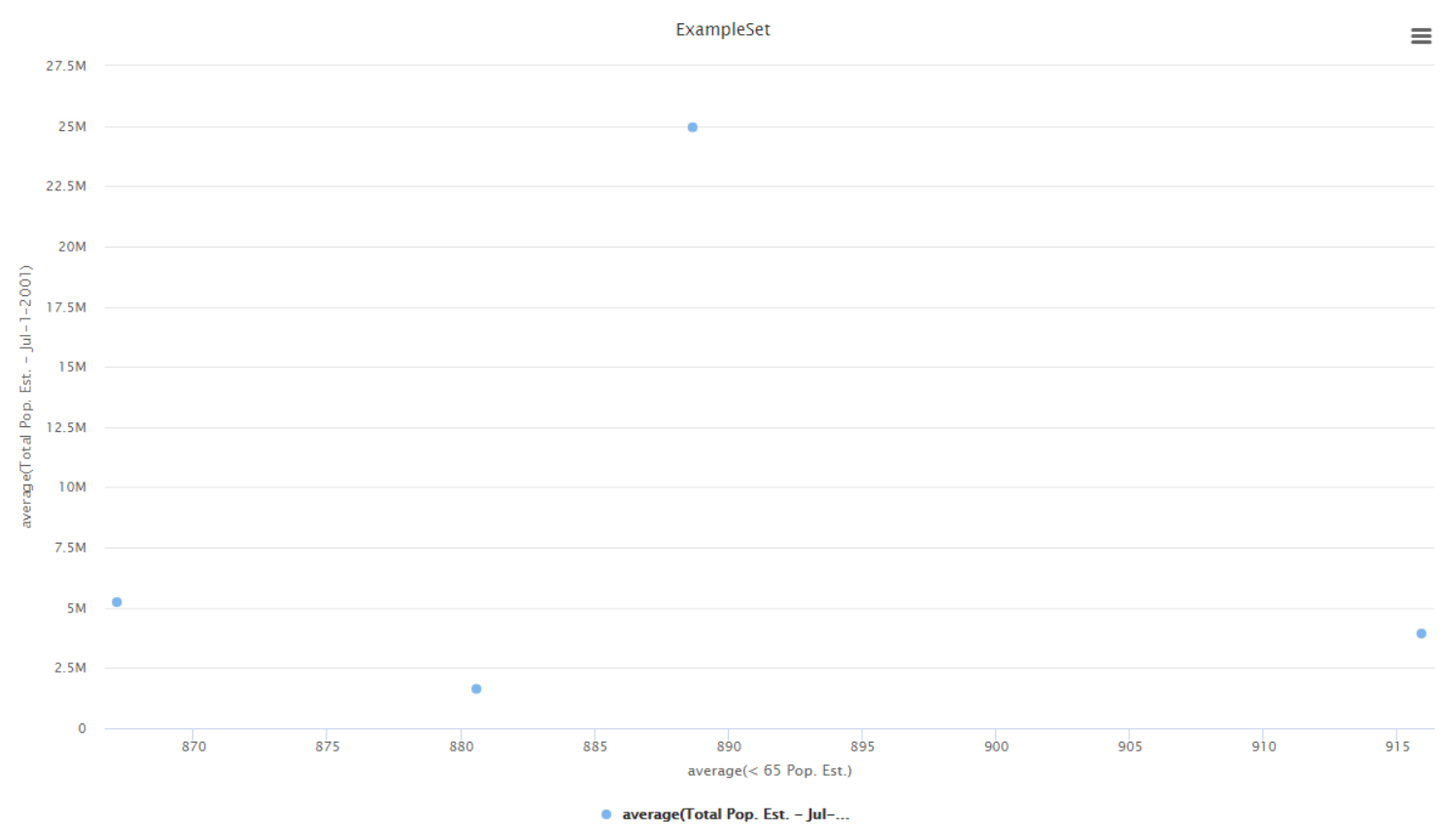

This scatter plot is regarding the original data set centroids

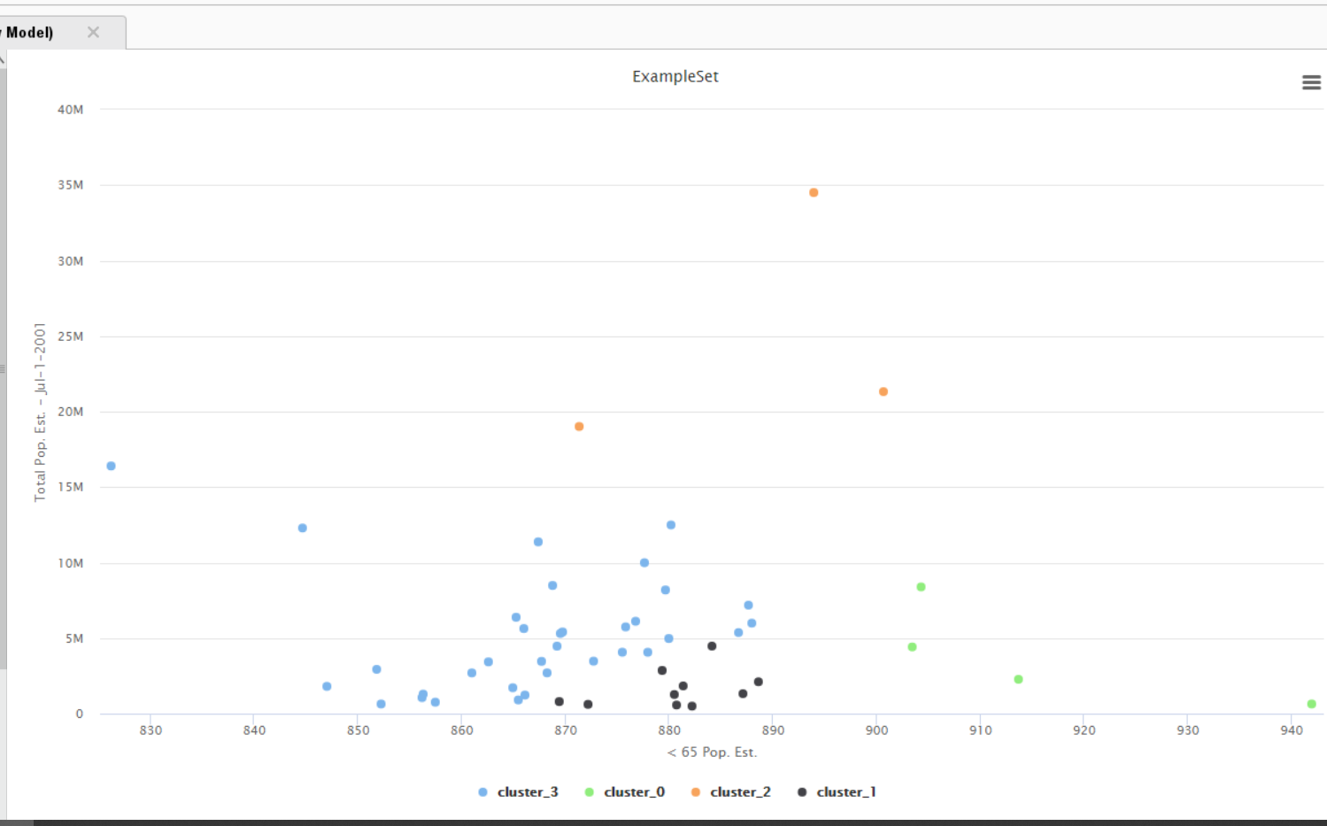

THIS IS THE VISUALIZATION OF SCATTER PLOT, it is scarce because of lesser no. of examples



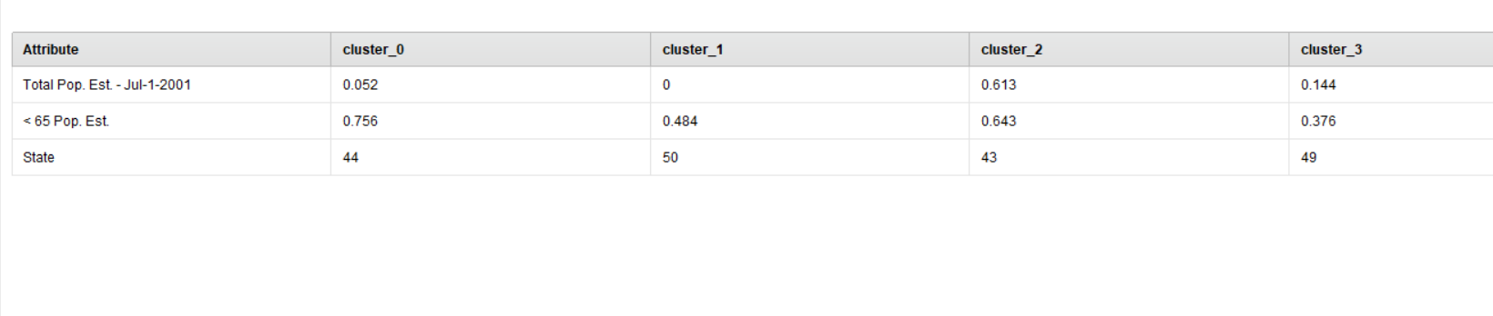

ID 44 corresponds to **Texas** state in table

ID 50 corresponds to **Wisconsin** state in table

ID 43 corresponds to **Tennessee** state in table

ID 49 corresponds to **West Virginia** state in table

* **Countries having total pop close to 3926577.50 and <65 pop close to 915 (similar to Texas) belong to Cluster 0**
* **Total pop close to** 1631436.600 **and <65 pop close to** 880.599 **(similar to Wisconsin) belong to 1**
* **Total pop close to** 24945842.000 **and <65 pop close to 888.679 (similar to Tennessee) belong to 2**
* **Total pop close to** 5233490.735 **and <65 pop close to** 867.158  **(similar to West Virginia) belong to 3**

|  |  |  |  |
| --- | --- | --- | --- |
|  |  |  |  |
|  |  |  |  |
|  |  |  |  |
|  |  |  |  |